

**MPhil in Machine Learning and, Machine Intelligence 2018-2019**

**Module Coursework Feedback**

Module Title: Probabilistic Machine Learning

Module Code: 4F13

Candidate Number: F606F

Coursework Number: 2

***I confirm that this piece of work is my own unaided effort and adheres to the Department of Engineering’s guidelines on plagiarism.***

Date Marked: Click here to enter a date. Marker's Name(s): Click here to enter text.

**Marker's Comments:**

**This piece of work has been completed to the following standard** *(please circle as appropriate)*:

|  |  |  |  |  |  |  |  |  |  |
| --- | --- | --- | --- | --- | --- | --- | --- | --- | --- |
|  | **Distinction** | | | **Pass** | | | **Fail (C+ - marginal fail)** | | |
| **Overall assessment**  **(circle grade)** | **Outstanding** | **A+** | **A** | **A-** | **B+** | **B** | **C+** | **C** | **Unsatisfactory** |
| **Guideline mark (%)** | 90-100 | 80-89 | 75-79 | 70-74 | 65-69 | 60-64 | **55-59** | **50-54** | **0-49** |
| **Penalties** | **10% of mark for each day, or part day, late (Sunday excluded).** | | | | | | | | |

The assignment grades are given **for information only**; results are provisional and are subject to confirmation at the Final Examiners Meeting and by the Department of Engineering Degree Committee.

Probabilistic Machine Learning cw2 – Probabilistic Ranking (1040 words)



The performance difference is added to the winner, but subtracted from the loser. This forms the means of all the players.

The diagonal represents the number of matches that a player has played. And the non-diagonal represents the number of matches a player i has played against the player j followed with a negative sign.

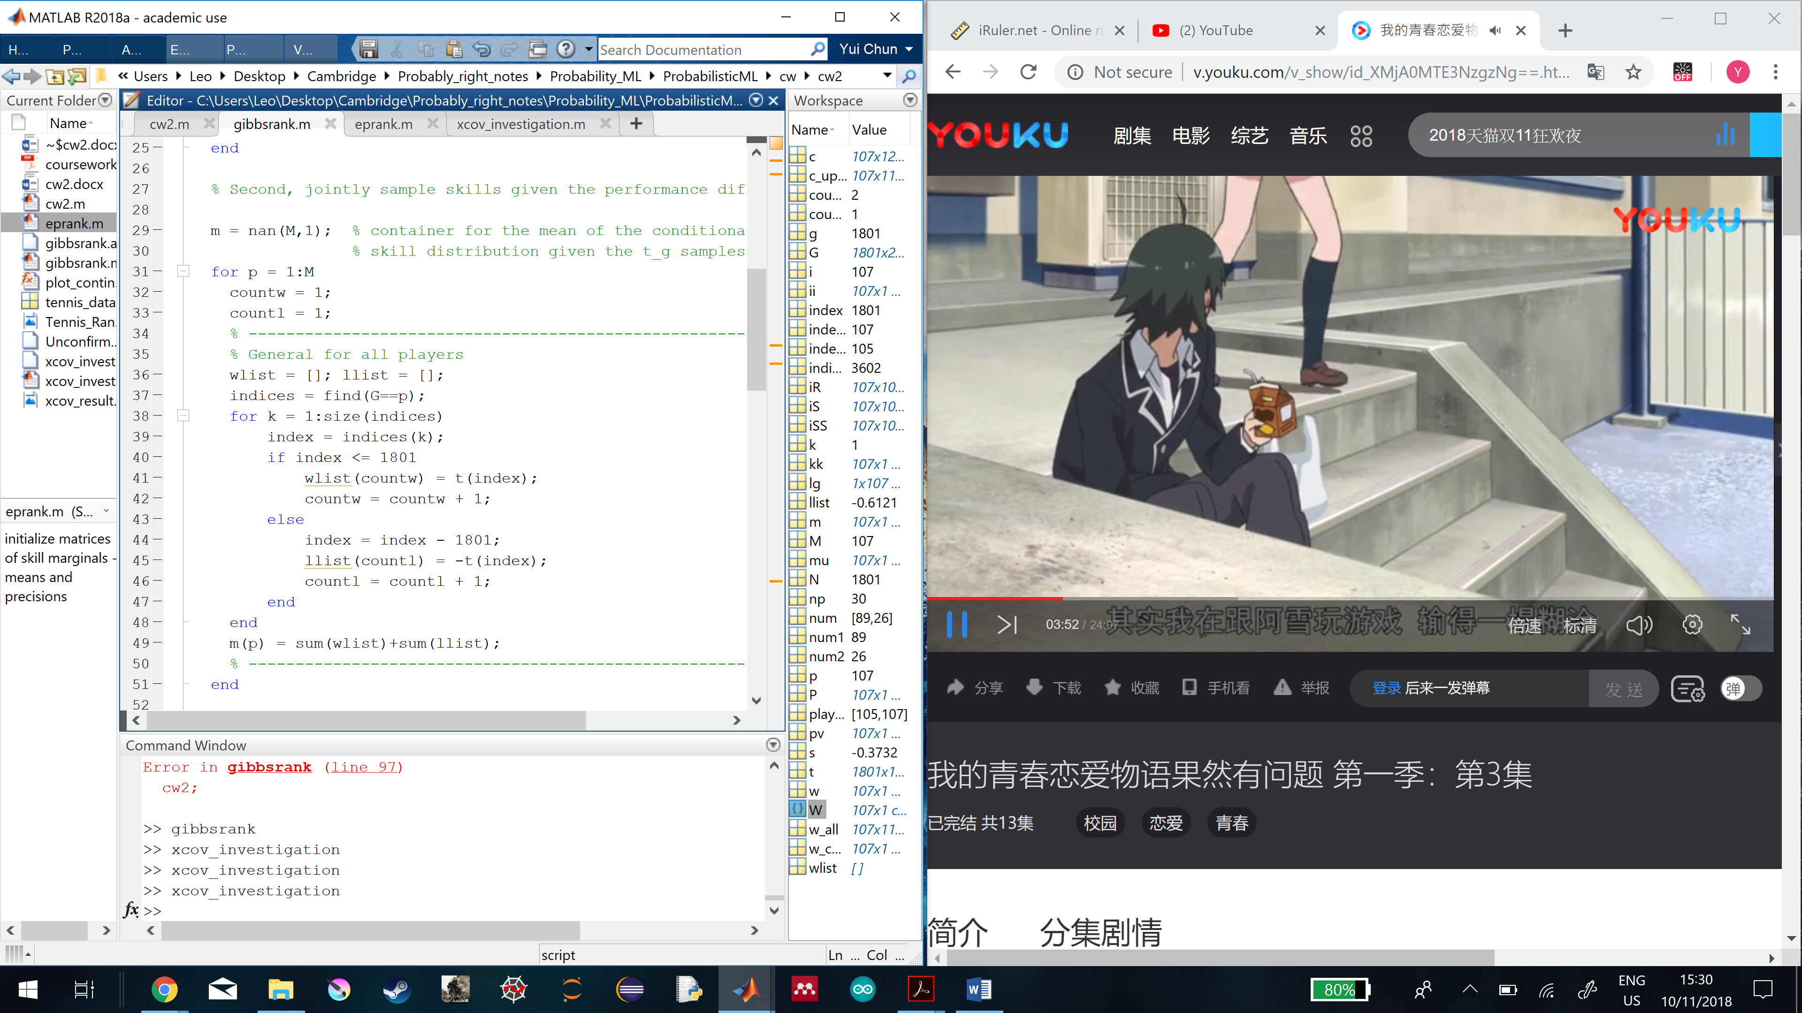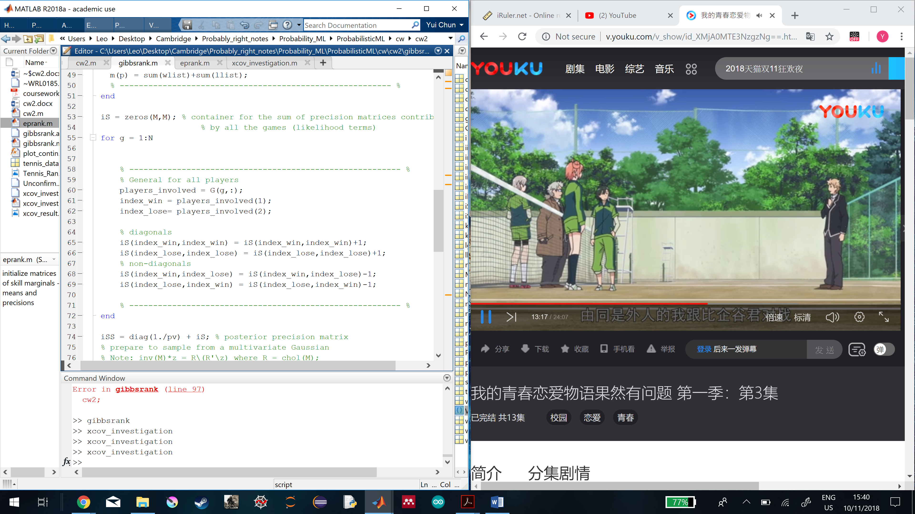

Figure 1: (left) contatiner for the mean of the conditional skill distribution given the $t_{g}$ samples. (right) container for the sum of the precision matrices distributed by all the games (likelihood terms)

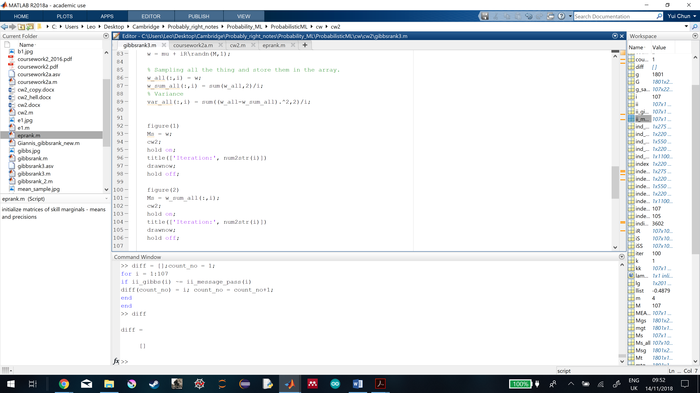

Figure 2 shows how all the samples from all iterations are stored in a matrix, and how the means and variances are computed for all iterations.

All iterations of skill samples for all players are collected to form a matrix of dimension 107x1100, which the ith column describes the skill samples of all players in ith iteration. The means and variances of the gibbs samples of all players are found in all iterations.

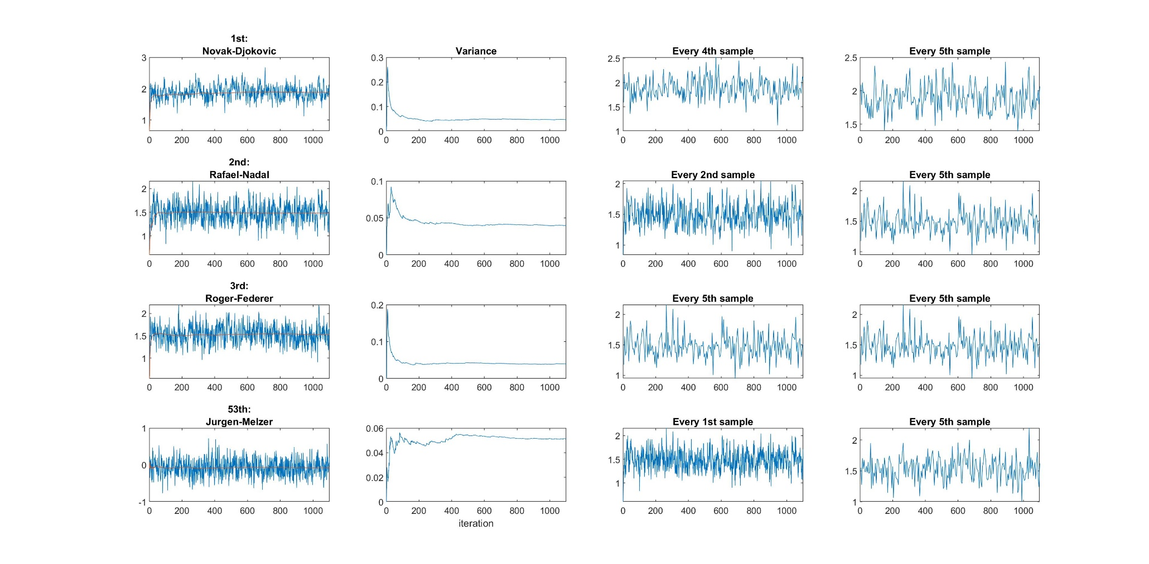

Figure 3: The 1st column shows all the samples of the player for 1100 iterations as the blue lines and the mean of the samples as the red lines. The 2nd column shows the variance changes over iteration. The 3rd column shows the mixing time for each player so that the samples can become independent. The 4th column shows when every 5th sample is sampled, samples from each player will still be independent.

From 1st column of figure 3, if each iteration of skill sample is from the same posterior distribution, the sample should be sampled around the mean and variance of the distribution. So, the gibbs sampler is able to move around the whole posterior distribution

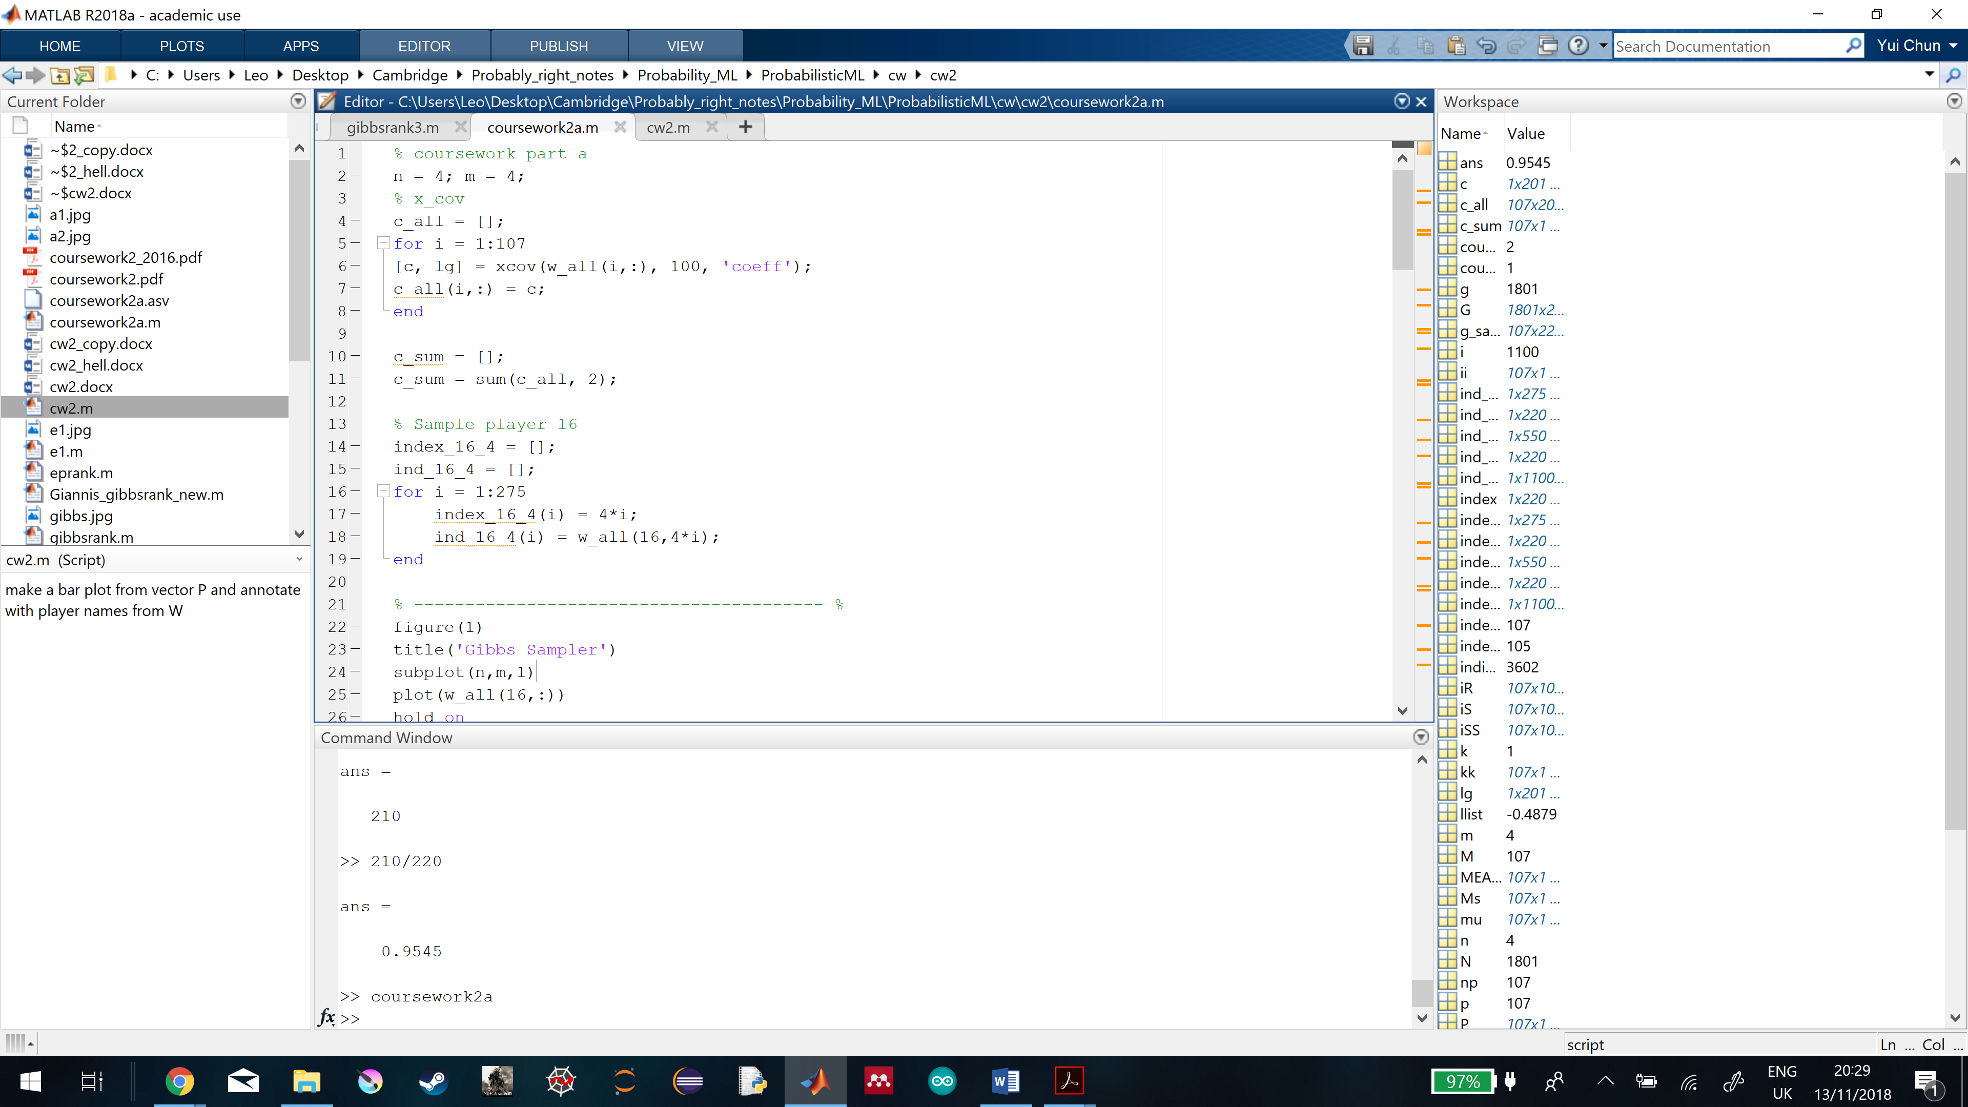

Figure 4 shows how the auto-covariance coefficients of each player can be found, and stored into a matrix which contains all the coefficients of all players.

To find the auto-covariance coefficients of each player, the row vector (1x1100) representing the player’s skills samples over all iteration is put into the xcov function which outputs the coefficient vector (1x201) as the coefficients. And the sum of all coefficients in the vector gives the mixing time for each player.

Comparing all these sums from the players, the peak mixing time is 5.7. If the player has the sum of lower than or equal to 1, it means every sample has to be sampled to achieve independence. But even though a higher mixing time is used to sample this player, his samples are still independent. So, the peak mixing time should be taken. And to divide 1100 iterations completely, so every 5th Gibbs sample is kept to achieve independent sampling.

Burn-in describes the practice of throwing away some iterations at the beginning of an Markov Chain Monte Carlo.

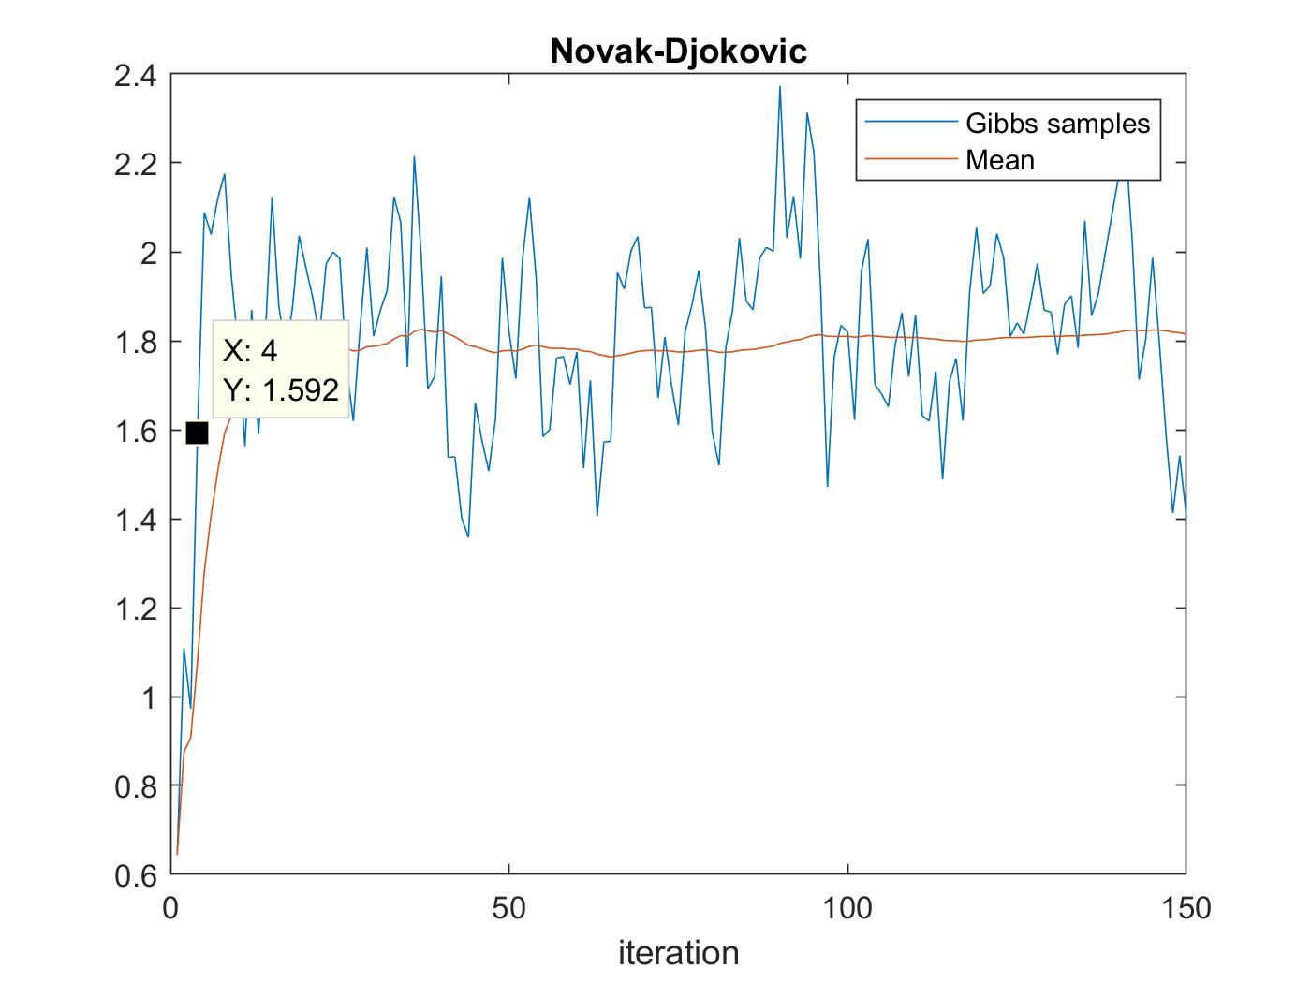

Figure 5 shows the burn-in time of the Markov Chain Monte Carlo algorithm.

When zooming in the gibbs samples in figure 5, there are always the first 4 samples are far away from the equilibrium distribution. So, they are the burn-in samples.



For the gibbs sampler, the convergence occurs when the samples from conditional posterior can approximate the joint posterior distribution. It converges when the mean and variance of the samples are stabilized.

From 1st and 2nd columns of the figure 3, the mean of the player’s skill begins to stabilize quite early, around 50th iteration. But the variance of the skill continues to flunctuate until 300th iteration. So the required iterations should be 300.

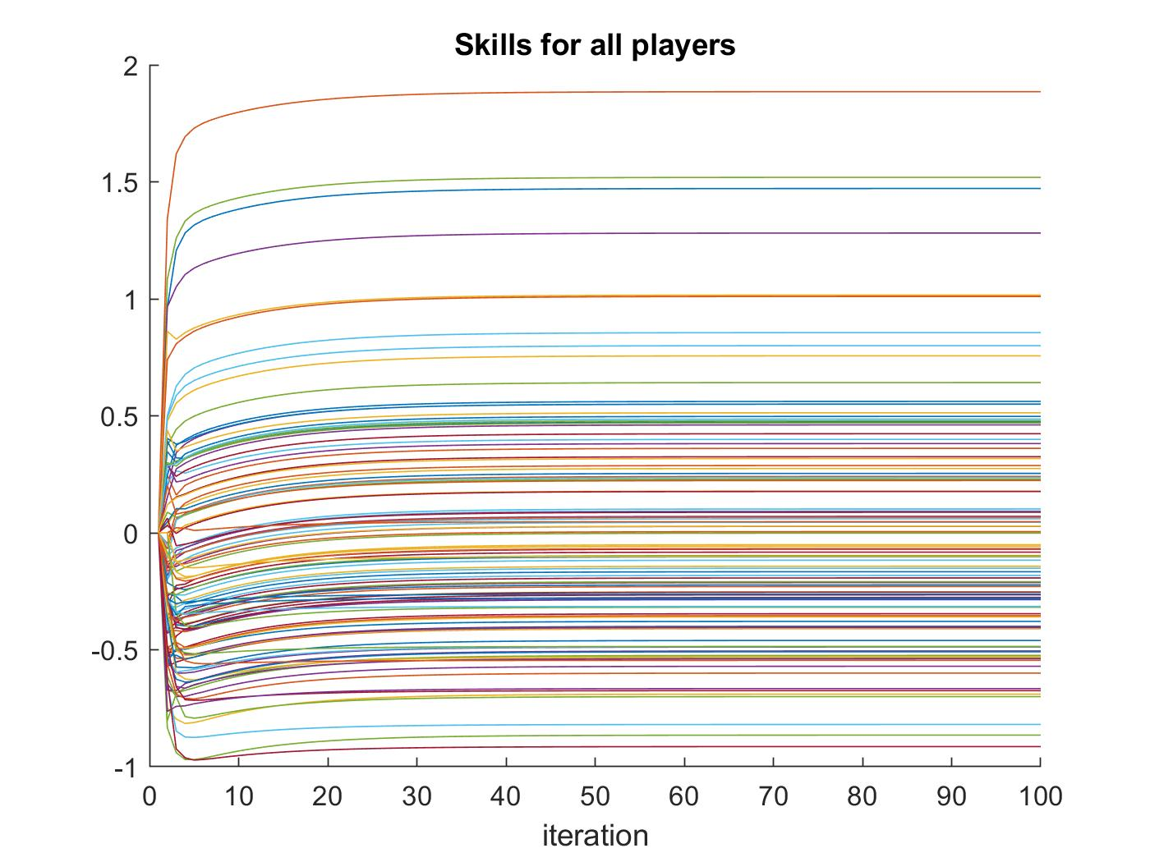

Figure 6 shows the changes of the skills for all players in 100 iterations.

In the message passing algorithm, it converges when the messages propagations can no longer update and change the distribution. From the figure 6 above, the skills of the players are getting updated continuously from the 1st to 20th iteration. But they converges after 30th iteration which is the number of iterations required.

Table 1 compares the ranks and skill means assigned by the gibbs sampler and message passing algorithm to the players.

|  |  |  |  |  |
| --- | --- | --- | --- | --- |
| Player | Gibbs sampler | | Message passing | |
| Rank | Skill mean | Rank | Skill mean |
| Novak-Djokovic | 1 | 1.8917 | 1 | 1.8854 |
| Rogel-Federer | 2 | 1.5349 | 2 | 1.5192 |
| Jurgen-Melzer | 53 | -0.0604 | 53 | -0.0825 |

After comparing all the rankings generated from gibbs sampler and message passing, they are found to be not identical. The skill means estimated by the algorithms are different. However, Both algorithms usually assign the same ranks to the strong players, especially for the top 10 players.



Table 2 shows the skill means and standard deviations of top 4 players computed by the message passing algorithm.

|  |  |  |
| --- | --- | --- |
| Player | Skill mean | Skill std |
| Djokovic, Novak | 1.8854 | 1.3731 |
| Nadal, Rafael | 1.4716 | 1.2131 |
| Federer, Roger | 1.5192 | 1.2325 |
| Murray, Andy | 1.2811 | 1.1319 |

The probability that the skill of one player is higher than the other can be computed by the joint prior probabilities over skills of two players given their skill means and variances.

$$p\left(w_{1},w_{2}\right)=N\left(w_{1};μ_{1},σ_{1}^{2}\right)N\left(w_{2};μ_{2},σ_{2}^{2}\right)$$

Assume that the skill of player 2 is greater than that of player 1 in the match, i.e. $w_{2}>w_{1}$, the probability is given by the following equations,

$$p\left(w_{2}>w_{1}\right)=p\left(w_{1}<μ_{2},w_{2}>μ_{2}\right)+p\left(w_{1}<μ_{1},w_{2}>μ_{1}\right)$$

$$=\int_{-∞}^{μ_{2}}{N\left(w_{1};μ_{1},σ_{1}^{2}\right)dw_{1}\int_{μ_{2}}^{∞}{N\left(w_{2};μ_{2},σ_{2}^{2}\right)dw_{2}}} + \int_{-∞}^{μ_{1}}{N\left(w_{1};μ_{1},σ_{1}^{2}\right)dw_{1}\int_{μ_{1}}^{∞}{N\left(w_{2};μ_{2},σ_{2}^{2}\right)dw_{2}}} \\ =normcdf\left(\frac{μ_{2}-μ_{1}}{σ_{1}},0,1\right)normcdf\left(0,0,1\right)+ normcdf(0,0,1)normcdf(\frac{μ_{2}-μ_{1}}{σ_{2}},0,1)$$

Table 3 shows the probability that the skill of one player is higher than that of another player. The players listed in the 1st column are assumed to have greater skills than those in the 1st row in the match.

|  |  |  |  |  |
| --- | --- | --- | --- | --- |
| Greater | Djokovic, Novak | Nadal, Rafael | Federer, Roger | Murray, Andy |
| Djokovic, Novak |  | 0.6260 | 0.6110 | 0.6867 |
| Nadal, Rafael | 0.3740 |  | 0.4845 | 0.5646 |
| Federer, Roger | 0.3890 | 0.5155 |  | 0.5799 |
| Murray, Andy | 0.3133 | 0.4354 | 0.4201 |  |

Probability of one player winning a match between the two is given the equation,

$$p\left(y = 1 | w_{1}-w_{2}\right)=\int_{-∞}^{a}{N\left(z;0,1\right)dz}=normcdf\left(a,0,1\right)$$

, where $a=w_{1}-w_{2}$, $w_{1}$ wins the match against $w_{2}$.

Table 4 shows how probable the players in the 1st column can win against those in the 1st row.

|  |  |  |  |  |
| --- | --- | --- | --- | --- |
| Winner | Djokovic, Novak | Nadal, Rafael | Federer, Roger | Murray, Andy |
| Djokovic, Novak |  | 0.6605 | 0.6429 | 0.7272 |
| Nadal, Rafael | 0.3395 |  | 0.4810 | 0.5755 |
| Federer, Roger | 0.3571 | 0.5190 |  | 0.5941 |
| Murray, Andy | 0.2728 | 0.4245 | 0.4059 |  |

Table 1 uses the prior skill probabilities of both players, to compute how probable one player is more skilful than the other. It computes $p\left(w_{2}>w_{1}\right)$.

Table 2 bases on their given skills means (without considering their prior skill probabilities and their skills variances) to judge how likely one player will win the other. It computes $p\left(y=1 | w_{1},w_{2}\right)$.

Table 1 favors players with lower skill means, and gives them higher probability of being more skilful than the opponent with higher skill means. Table 2 favors stronger players with higher skill means, and gives them higher probability to win.



Table 5 shows the skill means and standard deviations found by the gibbs sampler for the top 4 players.

|  |  |  |  |
| --- | --- | --- | --- |
| Player name | Player index | Skill mean | Skill std |
| Djokovic, Novak | 16 | 1.8917 | 0.2032 |
| Nadal, Rafael | 1 | 1.4807 | 0.1937 |
| Federer, Roger | 5 | 1.5349 | 0.1928 |
| Murray, Andy | 11 | 1.3021 | 0.2231 |



Assume that the marginal skills are defined as,

$$w_{i}∼N\left(μ_{i},σ_{i}^{2}\right)$$

Using the equations that compute Table 3 from part c, the probability that the player 1 has a better skill than player 16,

$$p\left(w_{1}>w_{16}\right)=0.0192$$

The probability that the player 16 has a better skill than player 1,



$$p\left(w_{16}>w_{1}\right)=0.9808$$

From 1100 iterations of skills samples from players 1 and 16, the first 4 samples are thrown away for the purpose of burn in time, and every 5th sample is taken because of the mixing time. What are left are the 220 effective samples for two players.

$$p\left(w_{1}>w_{16}\right)=\frac{\#\left(w_{1}>w_{16}\right)}{220}=\frac{10}{220}≈0.0455$$

$$p\left(w_{16}>w_{1}\right)≈0.9545$$

Table 6 shows the matches that player 1 played against player 16.

|  |  |  |
| --- | --- | --- |
| Match no. | Winner | Loser |
| 34 | 16 | 1 |
| 35 | 16 | 1 |
| 36 | 16 | 1 |
| 37 | 16 | 1 |
| 38 | 16 | 1 |
| 39 | 16 | 1 |

From the data G storing all the matches information (winner and loser), the matches that player 16 played against player 1 are extracted in Table 6.

The probability that player 16 wins the match against player 1 is 100%, which indirectly indicates the skill of player 16 is greater than that of player 1. So the first method is better since the probability from the first method (98.08%) is greater than that from second method (95.45%).

Using the first method, the table for the skills of the top 4 players is computed.

Table 7 shows the probability that the skills of 1st column players are greater than the those in 1st row.

|  |  |  |  |  |
| --- | --- | --- | --- | --- |
| Greater | Djokovic, Novak | Nadal, Rafael | Federer, Roger | Murray, Andy |
| Djokovic, Novak |  | 0.9808 | 0.9642 | 0.9970 |
| Nadal, Rafael | 0.0192 |  | 0.3896 | 0.8050 |
| Federer, Roger | 0.0358 | 0.6104 |  | 0.8690 |
| Murray, Andy | 0.0030 | 0.1950 | 0.1310 |  |

Table 8 shows the actual number of wins and the win rate of a player had against another player.

|  |  |  |  |  |
| --- | --- | --- | --- | --- |
| WIn | Djokovic, Novak | Nadal, Rafael | Federer, Roger | Murray, Andy |
| Djokovic, Novak |  | 6 (1) | 4 (0.8) | 2 (0.67) |
| Nadal, Rafael | 0 (0) |  | 3 (0.75) | 4 (0.8) |
| Federer, Roger | 1 (0.2) | 1 (0.25) |  | 0 (un-defined) |
| Murray, Andy | 1 (0.33) | 1 (0.2) | 0 (un-defined) |  |

Skills in reality are difficult to be measured. The only way to know their skills is by the record, assume that the skill is directly proportional to the game outcome, we compare Table 3, 7 and 8.

Table from part c has a less extreme estimate in the probability that one player has a better skill than the other one, since the variances from the message passing is relatively greater than those from the gibbs sampler. So the part c table favors the weaker players.

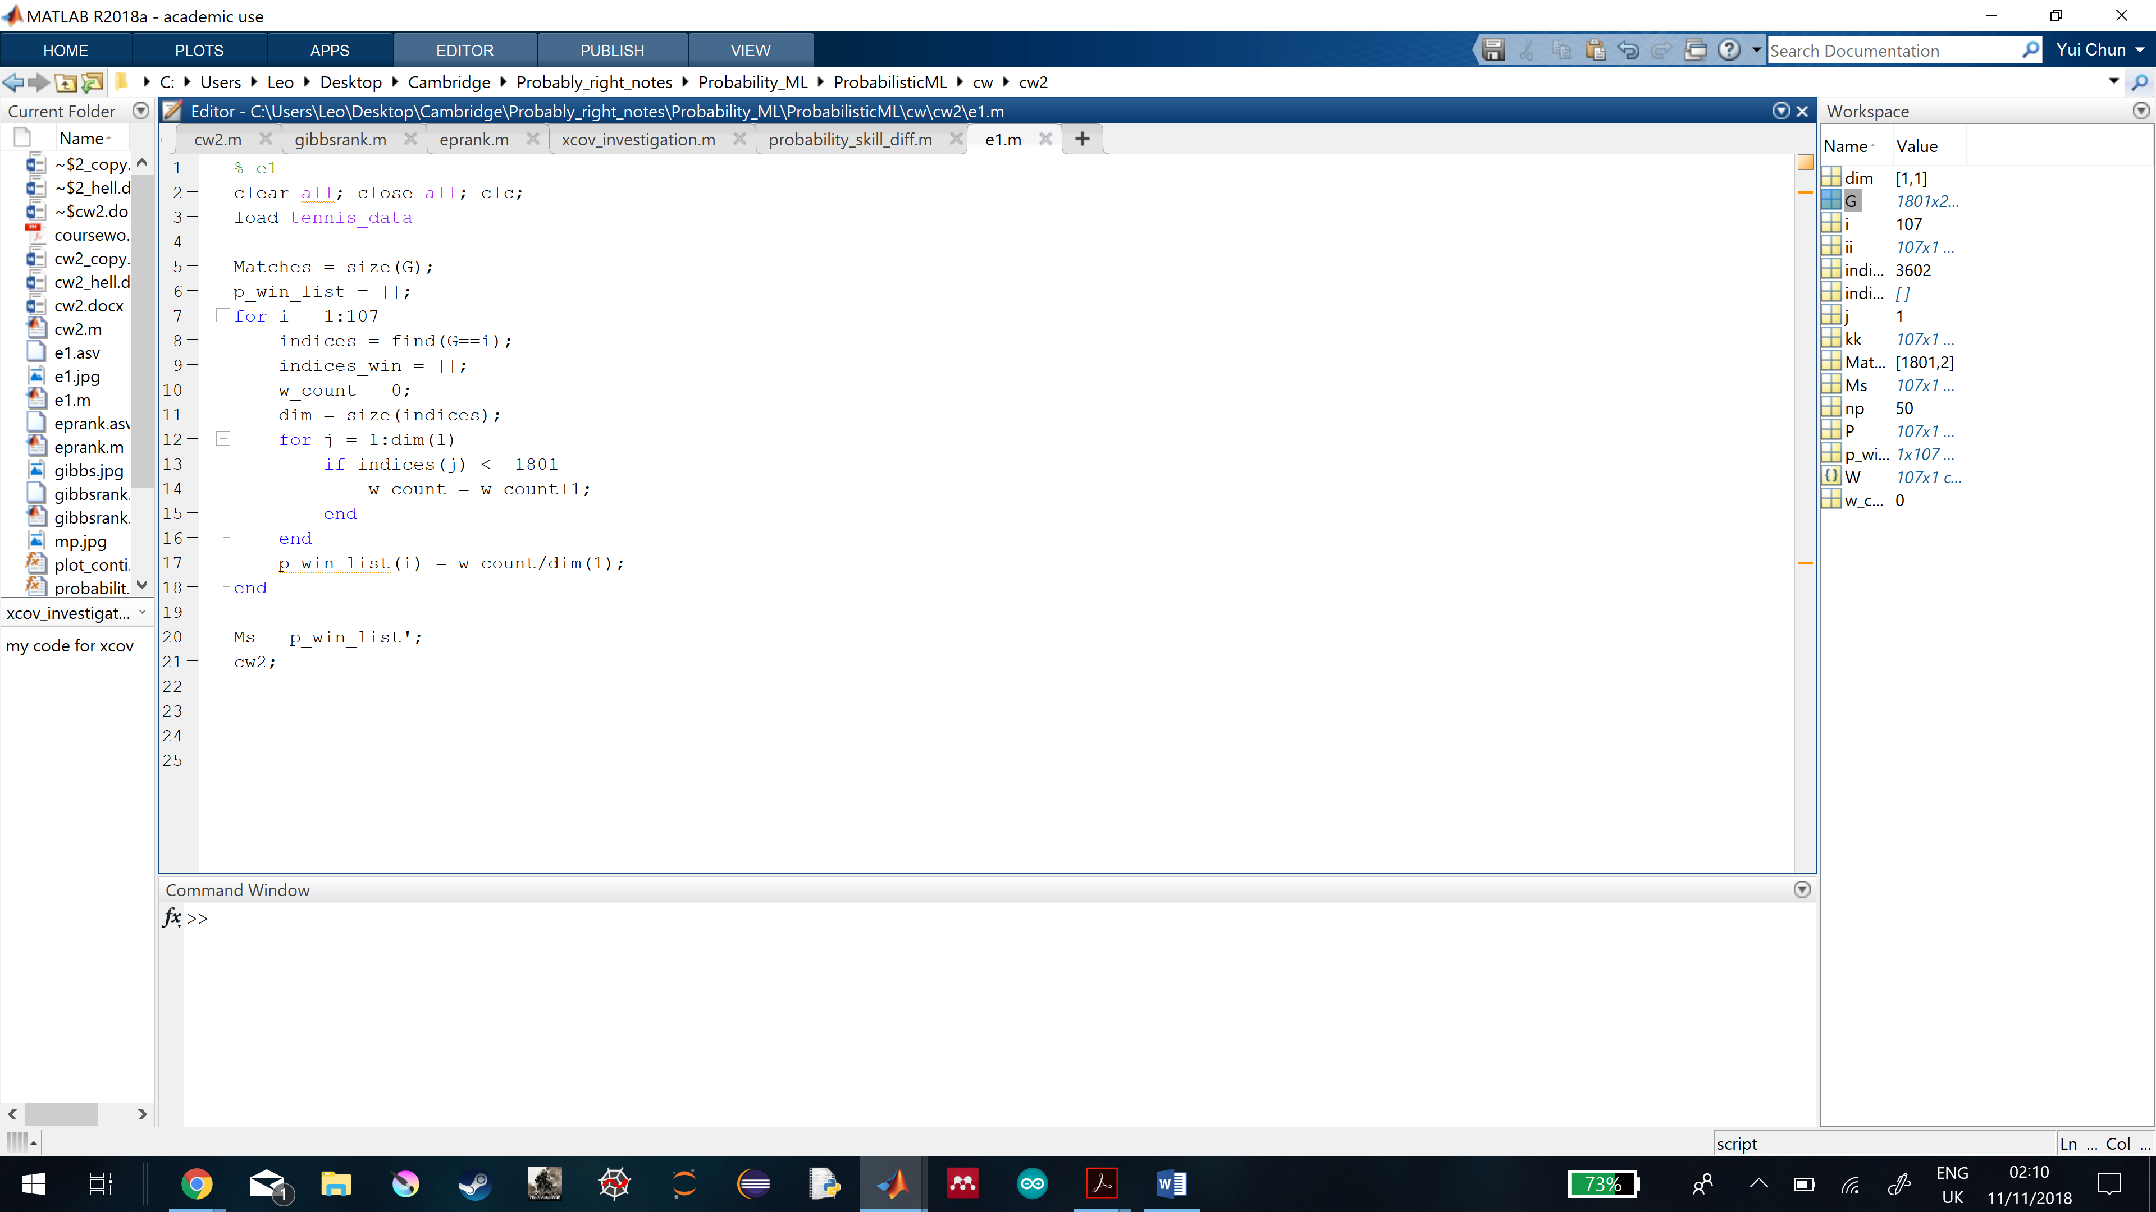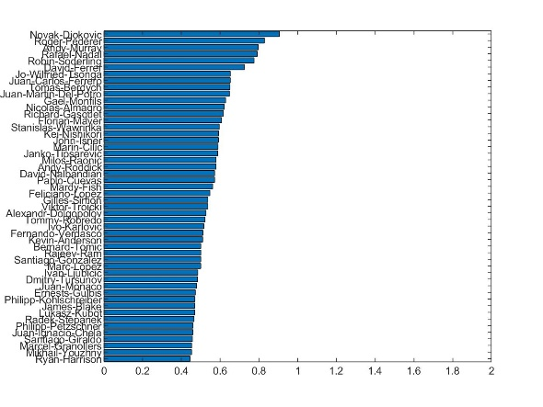

Figure 7 shows the codes used to extract empirical game outcome averages for all players on the left. The ranking of top 50 players is shown on the right.

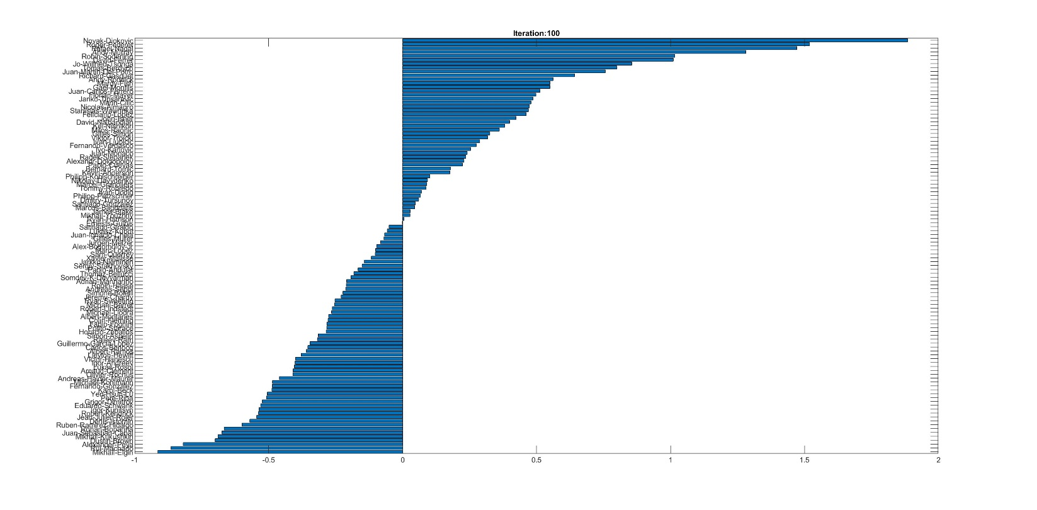

Figure 8 shows the ranking of skill means generated by the message passing algorithm for all players in 100 iterations.

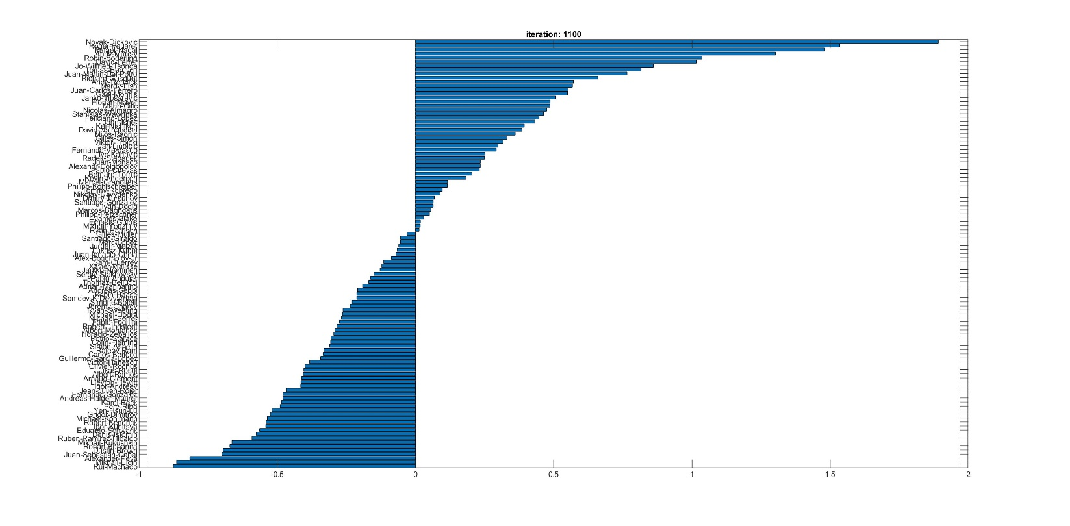

Figure 9 shows the ranking of the skill means generated by the gibbs sampler for all players in 1100 iterations.

The ranking based on empirical game outcome averages is not good estimate of the players’ skills and their game outcomes. Since those in the low ranks are often with no wins, their averages are always zeros. Then the ranking cannot distinguish their true ranks. The range used is also short from 0 to 1 only, which is not enough to distinguish all the players skills distinctively.

Both rankings generated by gibbs sampling and message passing algorithms use full range from -1 to 2. But gibbs sampler has more positive skill means players than the message passing one does.